
Touchstones Project
Netcards

Ritual Netcards with Text

Father’s Day HRJ
Juneteenth HRJ
Summer Solstice HRJ
Indigenous People’s Day HRJ

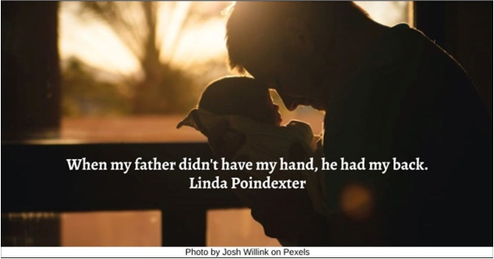

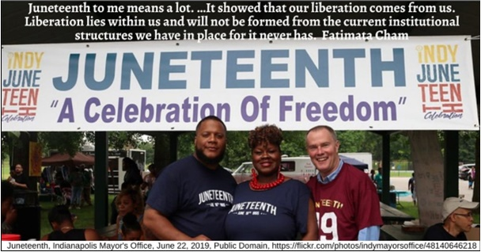

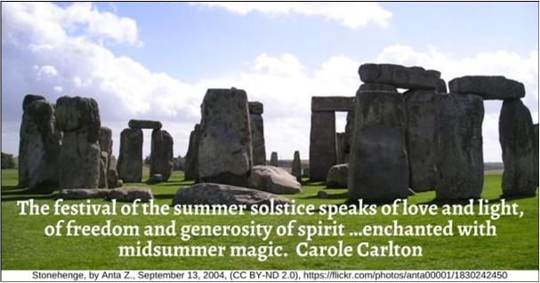

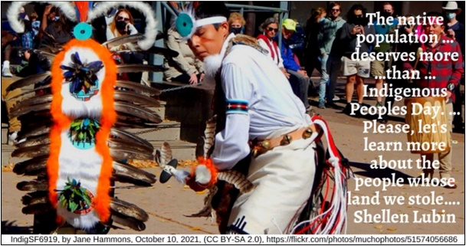

Pride HRJ
Bedtime Reading HRJ
Capitalism HRJ
Child with Candle HRJ

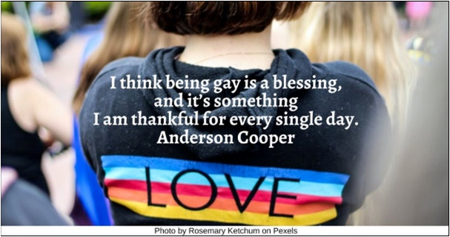

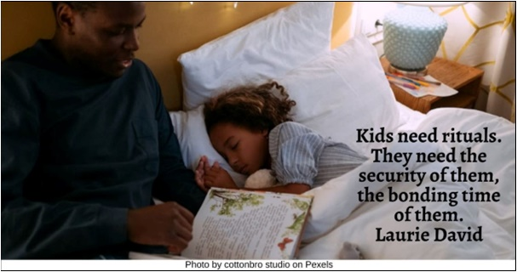

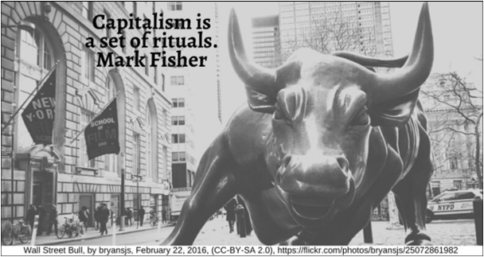

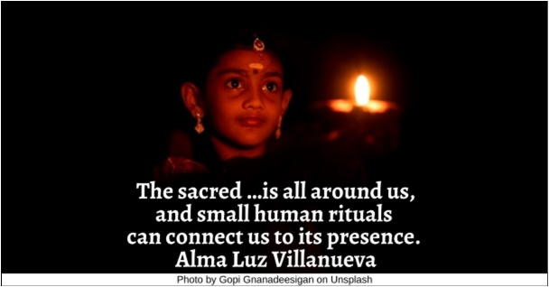

Couple HRJ
Drinking Tea HRJ
Family Meal HRJ
Field of Dreams HRJ

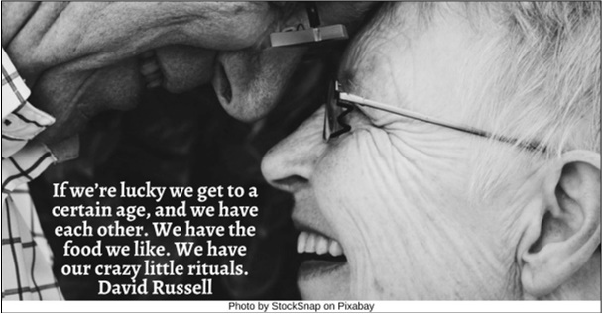

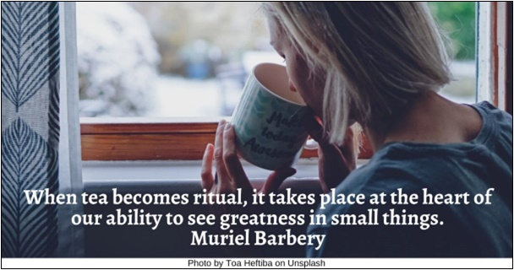

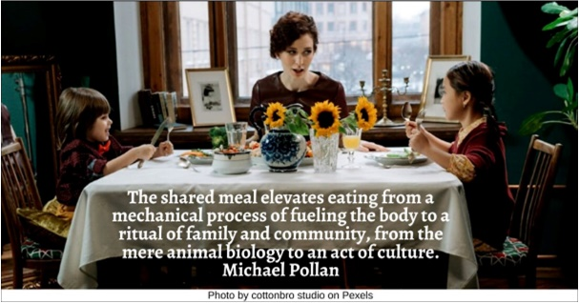

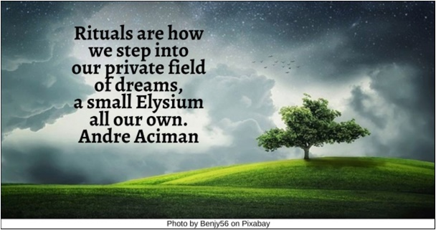

Flaming Chalice HRJ
Four Seasons HRJ
Galaxy HRJ
Holi HRJ

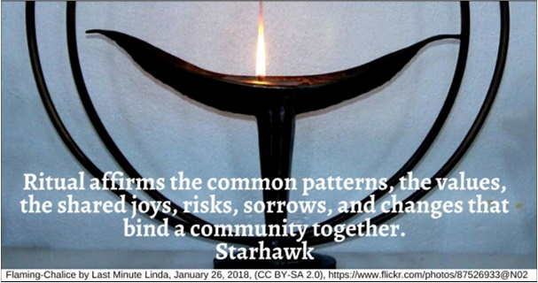

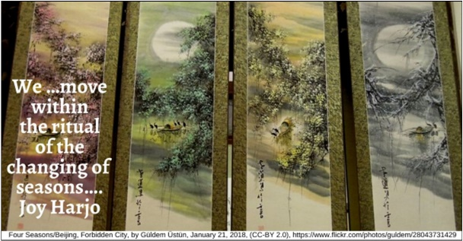

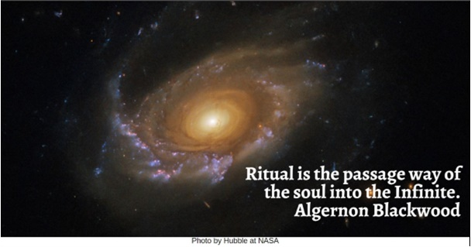

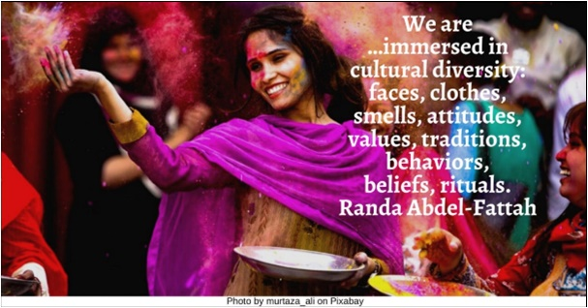

John Lennon HRJ
Lady Justice HRJ
Love HRJ
Night Sky HRJ

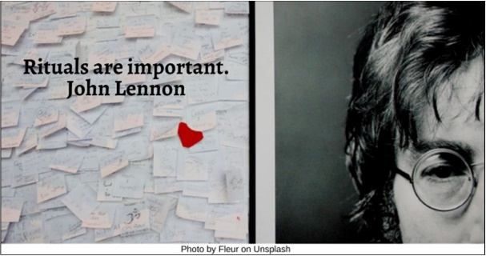

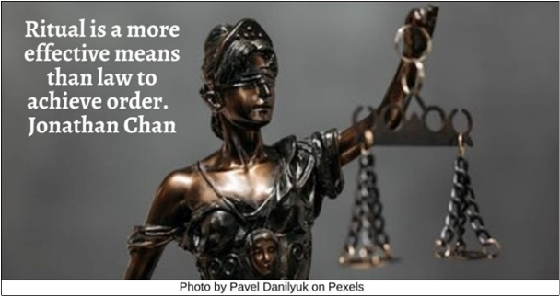

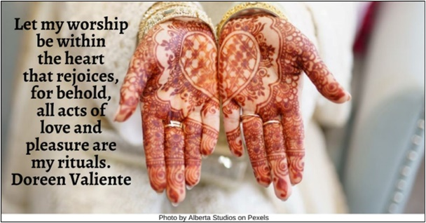

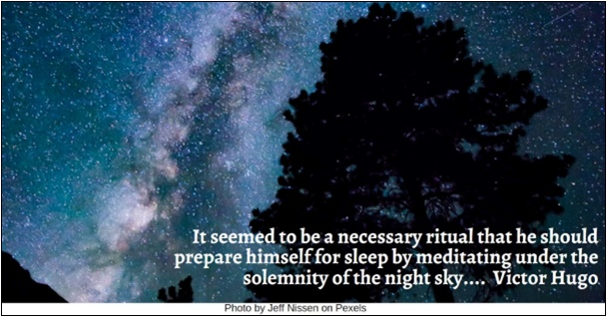

Outsider HRJ
Picnic HRJ
Poetry HRJ
Reading HRJ

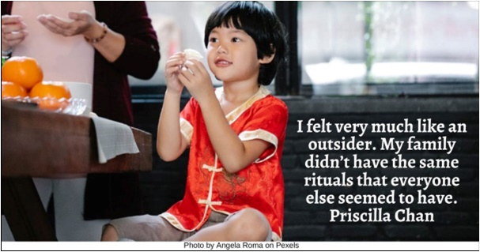

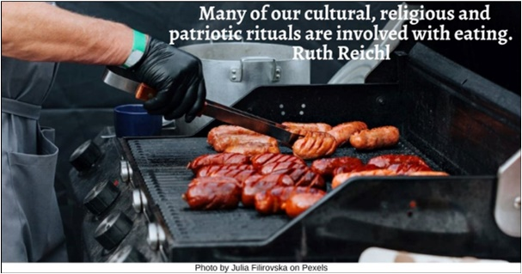

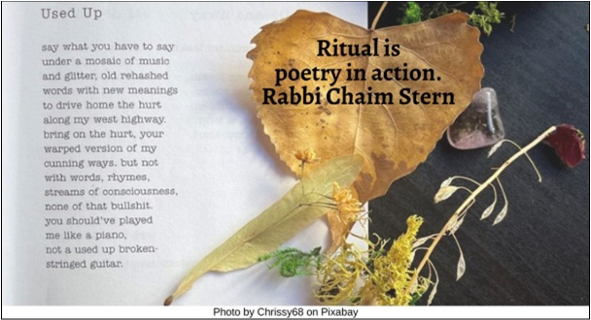

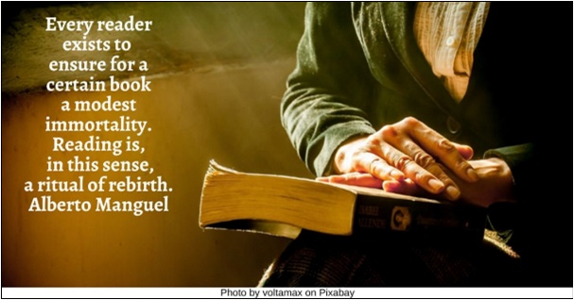

Reduce Anxiety HRJ
Sunrise HRJ
Superstitions HRJ
Tea Set HRJ

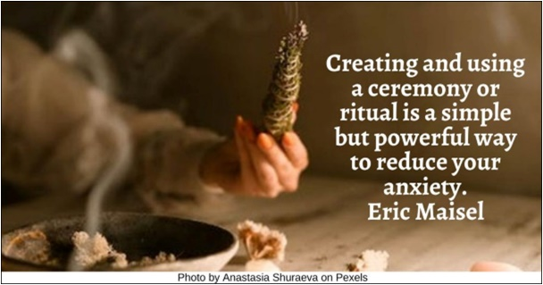

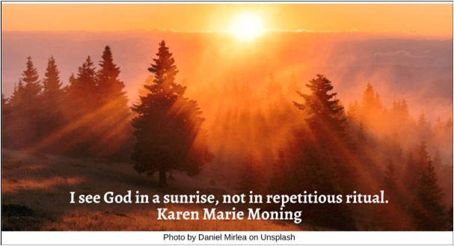

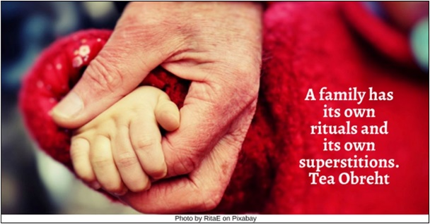

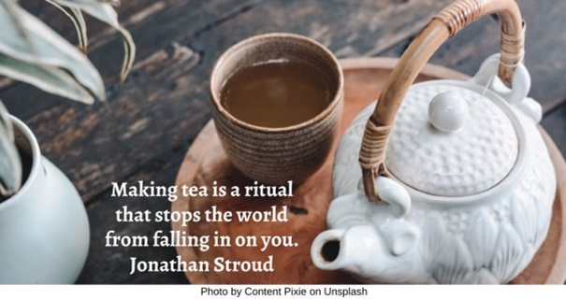

Time HRJ
Tying Shoes HRJ
Wedding HRJ

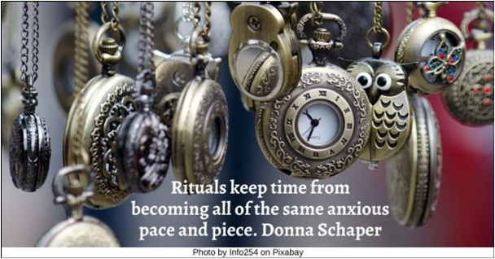

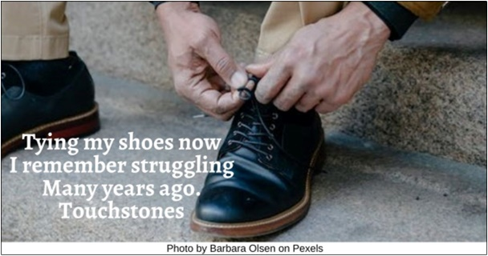

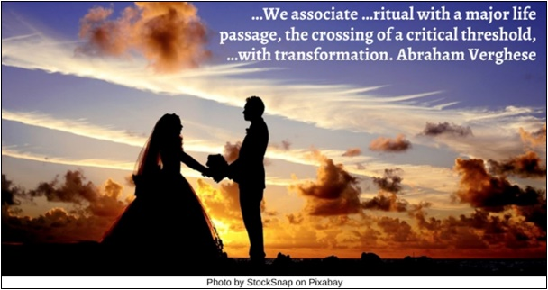

Text of Quotes
Father’s Day HRJ
When my father didn’t have my hand, he had my back. Linda Poindexter

Juneteenth HRJ
Juneteenth to me means a lot. …It showed that our liberation comes from us. Liberation lies within us and will not be formed from the current institutional structures we have in place for it never has. Fatimata Cham

Summer Solstice HRJ
The festival of the summer solstice speaks of love and light, of freedom and generosity of spirit …enchanted with midsummer magic. Carole Carlton

Indigenous People’s Day HRJ
The native population …deserves more …than …Indigenous Peoples Day. …Please, let’s learn more about the people whose land we stole…. Shellen Lubin

Pride HRJ
I think being gay is a blessing, and it’s something I am thankful for every single day. Anderson Cooper

Bedtime Reading HRJ
Kids need rituals. They need the security of them, the bonding time of them. Laurie David

Capitalism HRJ
Capitalism is a set of rituals. Mark Fisher

Child with Candle HRJ
The sacred …is all around us, and small human rituals can connect us to its presence. Alma Luz Villanueva

Couple HRJ
If we’re lucky we get to a certain age, and we have each other. We have the food we like. We have our crazy little rituals. David Russell

Drinking Tea HRJ
When tea becomes ritual, it takes place at the heart of our ability to see greatness in small things.
Muriel Barbery

Family Meal HRJ
The shared meal elevates eating from a mechanical process of fueling the body to a ritual of family and community, from the mere animal biology to an act of culture. Michael Pollan

Field of Dreams HRJ
Rituals are how we step into our private field of dreams, a small Elysium all our own. Andre Aciman

Flaming Chalice HRJ
Ritual affirms the common patterns, the values, the shared joys, risks, sorrows, and changes that bind a community together. Starhawk

Four Seasons HRJ
We …move within the ritual of the changing of seasons…. Joy Harjo

Galaxy HRJ
Ritual is the passage way of the soul into the Infinite. Algernon Blackwood

Holi HRJ
We are …immersed in cultural diversity: faces, clothes, smells, attitudes, values, traditions, behaviors, beliefs, rituals. Randa Abdel-Fattah

John Lennon HRJ
Rituals are important. John Lennon
Lady Justice HRJ
Ritual is a more effective means than law to achieve order. Jonathan Chan

Love HRJ
Let my worship be within the heart that rejoices, for behold, all acts of love and pleasure are my rituals. Doreen Valiente

Night Sky HRJ
It seemed to be a necessary ritual that he should prepare himself for sleep by meditating under the solemnity of the night sky.... Victor Hugo

Outsider HRJ
I felt very much like an outsider. My family didn’t have the same rituals that everyone else seemed to have. Priscilla Chan

Picnic HRJ
Many of our cultural, religious and patriotic rituals are involved with eating. Ruth Reichl

Poetry HRJ
Ritual is poetry in action. Rabbi Chaim Stern

Reading HRJ
Every reader exists to ensure for a certain book a modest immortality. Reading is, in this sense, a ritual of rebirth. Alberto Manguel

Reduce Anxiety HRJ
Creating and using a ceremony or ritual is a simple but powerful way to reduce your anxiety. Eric Maisel

Sunrise HRJ
I see God in a sunrise, not in repetitious ritual. Karen Marie Moning

Superstitions HRJ
A family has its own rituals and its own superstitions. Tea Obreht

Tea Set HRJ
Making tea is a ritual that stops the world from falling in on you. Jonathan Stroud

Time HRJ
Rituals keep time from becoming all of the same anxious pace and piece. Donna Schaper

Tying Shoes HRJ
Tying my shoes now / I remember struggling / Many years long ago. Touchstones

Wedding HRJ
…We associate …ritual with a major life passage, the crossing of a critical threshold, …with transformation. Abraham Verghese

